- DATE
From the 8th to 10th October 2021

- PLACE
Swimming Pool “Za Lužánkami” – Brno, Czech Republic
Sportovní 486/4
602 00 Brno-město, Brno-Ponava
GPS: 49°12'51.975"N, 16°36'25.082"E

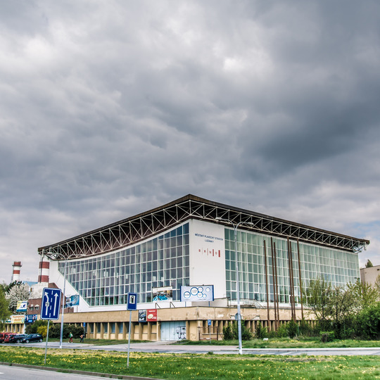

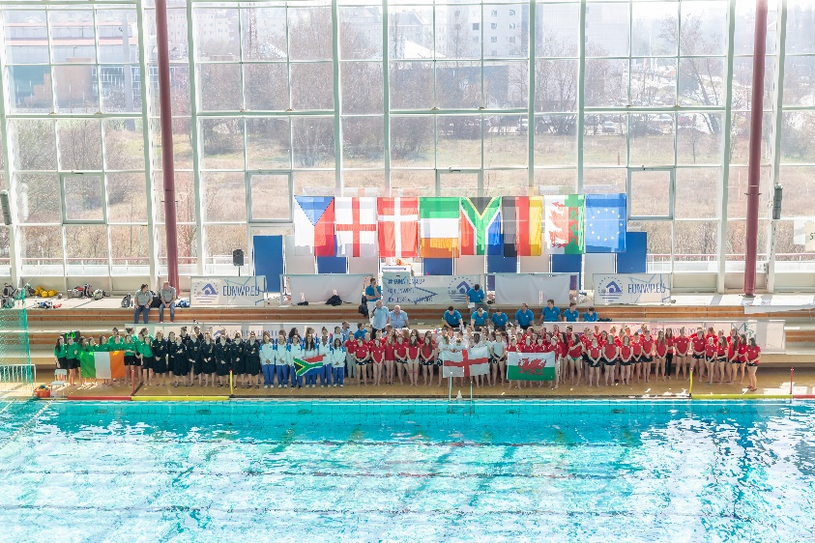

- PARTICIPANTS
Austria, Czech Republic, England, Lithuania, South Africa, Slovakia

Tournament will be played round robin system.

- TOURNAMENT RULES
The tournament is organized on the following rules:
1. With 6 teams participating there will be round-robin system.
2. Caps. Players must keep the same cap numbers for the duration of the tournament. The first goalkeeper should wear the number 1 red cap and the second goalkeeper red number 13 cap. In the event that an outfield player has to play in goal, he shall wear the red goalkeeper’s cap and the coach must inform the referees /table of the player’s original number.
3. Match Sheets. Each team must list their squad of up to 15 players before the start of their first match. In the event that a team has 14 or 15 players, they must inform the table one hour before each match which 1 or 2 players are not playing.
4. The first named team will play in White caps and defend the goal to the left of the Table.
5. Brutality. Any player excluded for the remainder of the game without a substitute for 4 minutes, for brutality shall be suspended for at least the next game. The Tournament Delegate and/or the Tournament Director may impose a greater penalty due to the nature of the brutality.
6. Yellow and Red Cards. Any head coach who addresses comments to, at or about the referees will receive a yellow card. Further transgressions will result in a red card being issued. Any other coach, official or player who addresses comments to, at or about the referees will receive a red card.
7. A coach, player or another official who receives a red card will be suspended for at least the next game. The Tournament Delegate and/or the Tournament Director may impose a greater penalty due to the nature of the offense.
8. Team Benches. All players not in the water at a given time must remain seated at the team bench at all times.
9. Results. Points shall be awarded as follows:
i. Win - 3 Points
ii. Draw - 1 Point
iii. Loss - 0 Points
10. Time Outs. Each team will be allowed 2 Time outs per game.
11. Teams MUST be ready to commence games at scheduled start times.
12. Each participating Nation MUST bring with them 1 International Qualified referee (LEN / FINA). Otherwise the Organizing Committee will source one at a cost of € 2000.00 to that Federation.
13. ALL costs must be paid in full 1 month before the event by bank transfer to EU Nations Group. Failure to do so may result in being removed from the Tournament.
14. Any protests must be made in writing within 30 minutes of the completed game, together with a protest fee of € 100 to the Delegate or the Tournament Director.
15. 2021 Junior tournaments are for players born in 2004 or younger. At the Technical Meeting on Thursday evening ALL passports will be checked by Tournament Officials.
16. The coach and team manager should look the same and shorts, flip flops etc. are not allowed.

- AWARDS
- Trophy for the 1st, 2nd and 3rd teams, commemorative awards for all teams
- Trophy for the Best Scorer (In case of equality, the youngest)
- Trophy for the Best Goal Keeper (Coaches decision)
- Trophy for the Best Player (Coaches decision)

- PROGRAM

Game No. | Group / Place | Time | White | Blue
Thursday 7th October | training
 |  | 1900 | CZE x AUT x LTU
 |  | 2000 | RSA x ENG x SVK
 | Technical meeting | 2100 | At the pool restaurant.
Friday 8th October
1 |  | 0920 | CZE | AUT
2 |  | 1040 | ENG | SVK
3 |  | 1150 | LTU | RSA
4 |  | 1720 | ENG | LTU
5 |  | 1830 | SVK | AUT
6 |  | 1940 | CZE | RSA
Saturday 9th October
7 |  | 0920 | SVK | LTU
8 |  | 1030 | CZE | ENG
9 |  | 1140 | AUT | RSA
10 |  | 1720 | LTU | AUT
11 |  | 1830 | RSA | ENG
12 |  | 1940 | SVK | CZE
 | Official Dinner | 2100 | Hotel Avanti
Sunday 10th October
13 |  | 0920 | LTU | CZE
14 |  | 1030 | AUT | ENG
15 |  | 1140 | RSA | SVK
 | Medal Ceremony | 1300

- ACCOMMODATION AND TRANSPORTATION

Point of contact is Mr. Andrej Janicek, he knows everything. His phone number is 00420777757266. In case of emergency, call 00420777632990.

Accommodation for All teams, referees and tournament officials and meals will be in Hotel Avanti (5 minutes on foot from the swimming pool).

AVANTI Hotel****
Střední 61
602 00 Brno
GPS: 49°12'46.179"N, 16°36'16.662"E

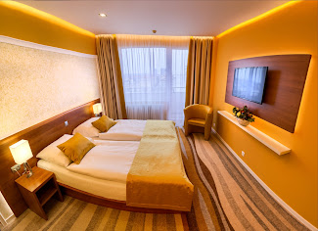
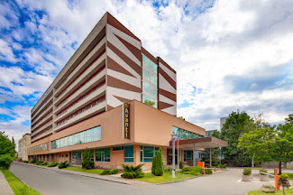

To have your accommodation easier, have the attached form “List of Guests” filled, printed and signed by all members of your team. Hand it out to the reception.

Transportation:
…

- TEAMS DECLARATION FORM

Nation:
Players:
 | First name |  | Surname |  | Date of Birth | Passport Number
1
2
3
4
5
6
7
8
9
10
11
12
13
14
15
Team officials:
16 | Position | First name |  | Surname |  | Passport Number
17 | Head Coach
18 | Assistant Coach
19 | Team Manager
20 | Doctor
21 | Physio
22 | Referee

Point of contact “on spot“ during the torunament:
Name: Telephone number:

This form is to be returned to jakub.picka@centrum.cz and stephenobrien3@icloud.com
NOT later than 22nd September 2021

- TRAVEL / ACCOMMODATION INFORMATION

Nation: __________________________________

Travel Details:
Arrival Date: Time:
Airport: Flight Number:
Departure Date: Time:
Airport: Flight Number:
Total Number in Group: ____________

We want transport from and to the airport provided: yes / no

Accommodation Requirements:
Number of Nights in Hotel: ________________
Single Rooms (€25 supplement) € 110 p/night: ________________
Number of persons in DBL/TRP/QDR Rooms (€ 85 p/person/night): ________________

Confirmed by: _________________________ Date: ______________________

This form is to be returned to jakub.picka@centrum.cz and stephenobrien3@icloud.com
NOT later than 22nd September 2020

- ADDITIONAL INFORMATION

Technical meeting:
Thursday 7th October at 2100 at the pool restaurant. Present should be the referee and one team representative from each of the teams with passports and TEAM LIST to be handed over to the organizers.
Meals:
All meals will be served at the hotel, teams should inform reception at the technical meeting for their lunches and dinners times. Free bottles of water will be provided at the pool for the games. Please state your special dietary requirements.
Official dinner:
Saturday 9th October 2100 at the Hotel Avanti restaurant.
Matches:
In the schedule attached above. Everything is indoors. Matches begin with anthems and line-up only Sunday.

Warm-up:
Indoors on the side of the field at the diving tower (deep water), 2 rows, one for each team. It is exclusively for the teams so balls can be used there etc. 5 balls will be provided for each team for the warm-up session at the jury table where they should be returned after the warm-up. Warm-up is also possible in the field after the end of the game and before the new game starts.
Entrance:
The team (coach) will get chips from the lockers in the morning and give it back at the end of the day at the reception. If lost then there is 50 EUR fine a piece. The referee will have chips all weekend long.

Covid-19:
…

LIST OF GUESTS
Surname | First Name | Date of Birth | Passport (ID) Number | Street | City | Signature

